David Allen

G00375372

Week 2

**Contains**: Photo of team, team name, team members name, student ID’s, hobbies and roles within team. Also, GitHub project location.

Blade Runner

Project Management

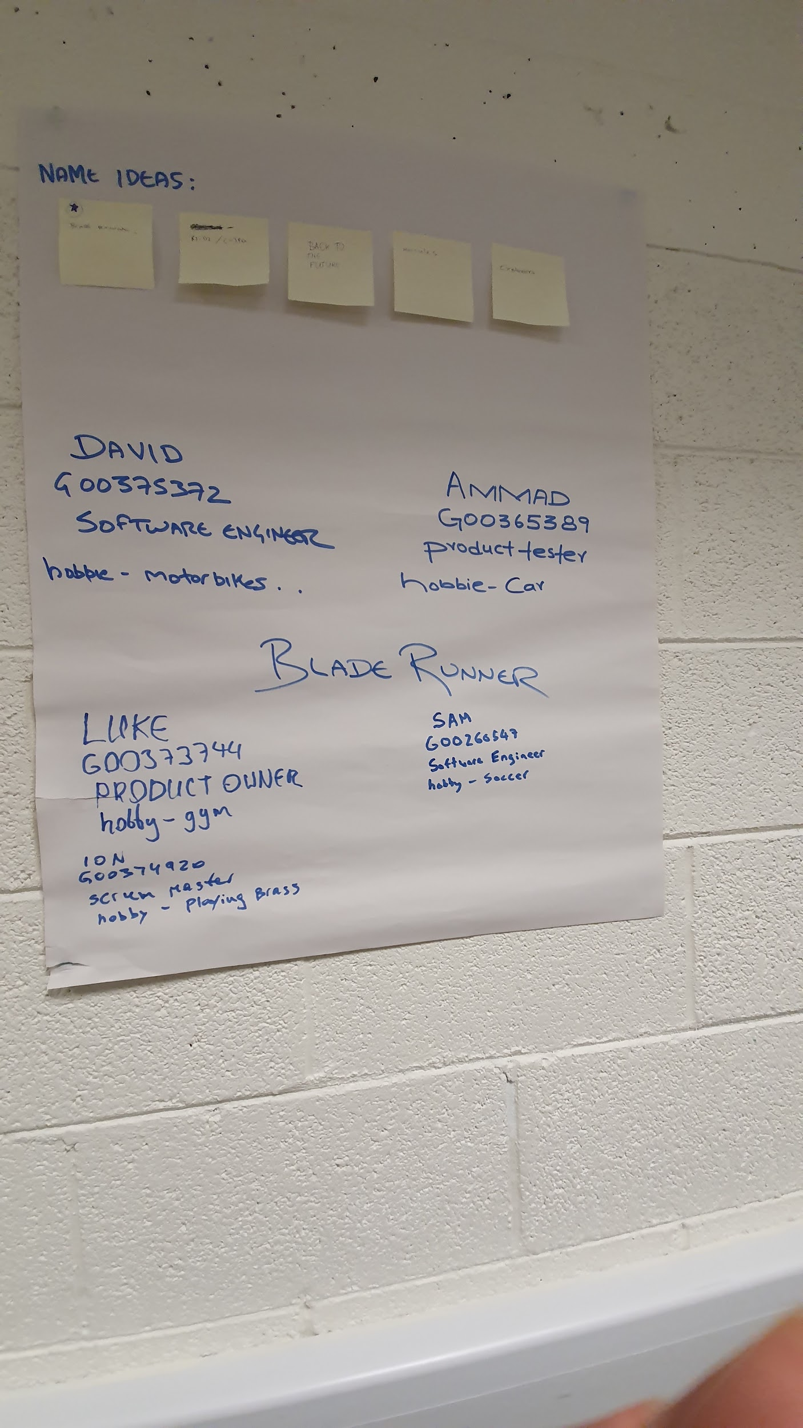Idea board containing project name; Blade Runner. All team members names, hobbies, Student ID and their roles within the team are shown:

Student ID’s of all team members:

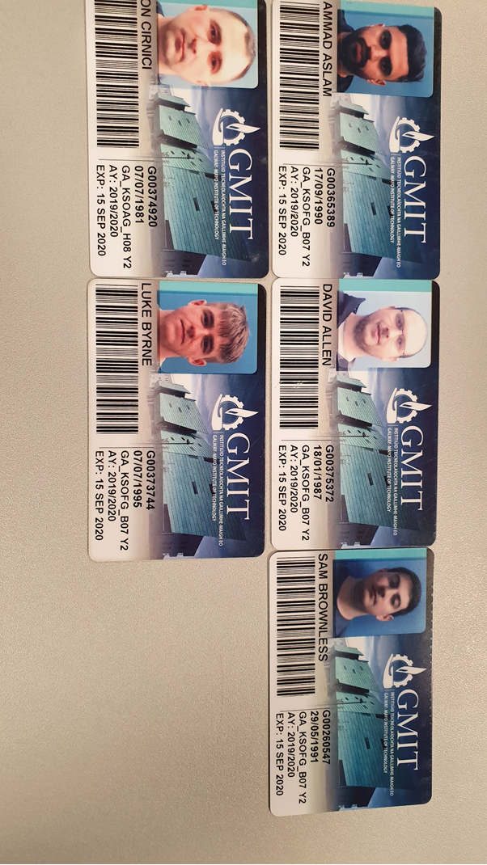

Picture of all team members of project Blade Runner:

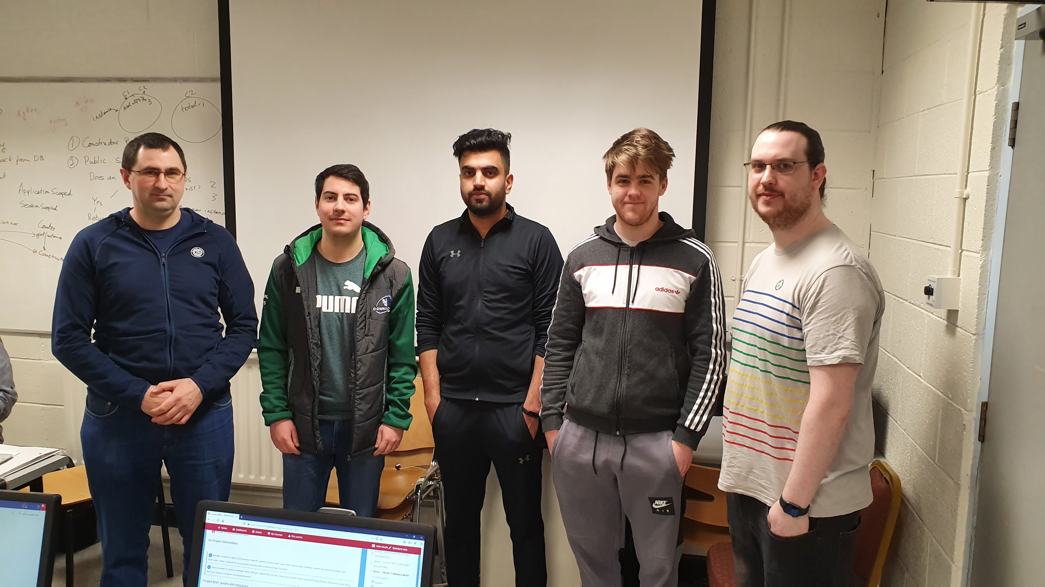

GitHub has been set up for the project and the repository for Blade Runner:

https://github.com/samBrownless16/BladeRunner_Project.git